WALMART SALES DATA ANALYSIS
A Data Analytics Project Using Python
Submitted By
Soham Shukla
Bachelor of Engineering (Computer Science & Engineering)

Tools & Technologies Used
- Python
- Pandas
- NumPy
- Matplotlib
- Seaborn
- Google Colab

Dataset
Walmart Sales Dataset
(6435 Records, 8 Features)

Project Submitted In Partial Fulfillment Of:
Data Analytics / Python Programming Project

Academic Year
2026 – 2027

Walmart Sales Data Analysis
1. Introduction
Walmart is one of the world's largest retail chains. Understanding sales trends and customer purchasing behavior is important for business growth and decision-making. This project analyzes Walmart's weekly sales data to identify sales patterns, seasonal trends, top-performing stores, and the impact of holidays on sales.

2. Objectives
The objectives of this project are:
• Analyze weekly sales performance across Walmart stores.
• Identify top-performing stores based on total sales.
• Study monthly sales trends.
• Compare holiday and non-holiday sales.
• Examine relationships between sales and economic indicators.
• Generate business insights using Exploratory Data Analysis (EDA).
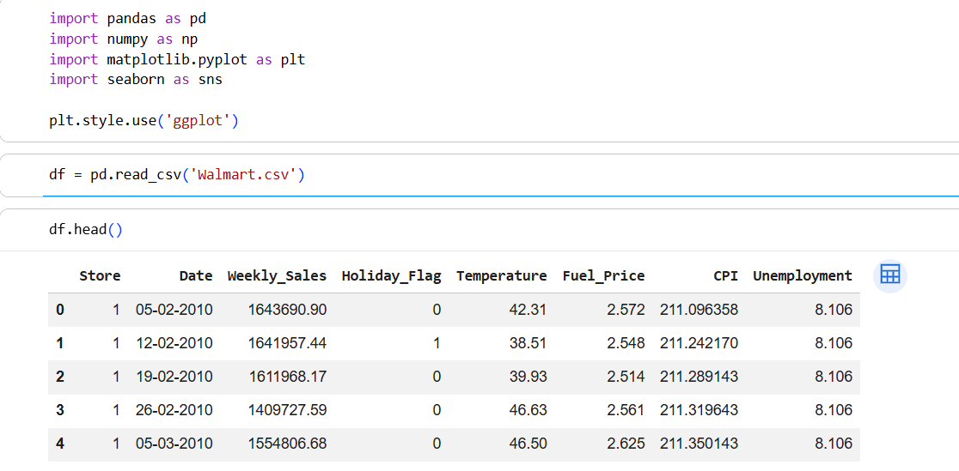

3. Dataset Description
The dataset contains 6,435 records and 8 features.
Dataset Features
- Store – Store identification number
- Date – Weekly sales date
- Weekly_Sales – Weekly revenue generated
- Holiday_Flag – Indicates whether the week contains a holiday
- Temperature – Average temperature during the week
- Fuel_Price – Fuel cost
- CPI – Consumer Price Index
- Unemployment – Unemployment rate
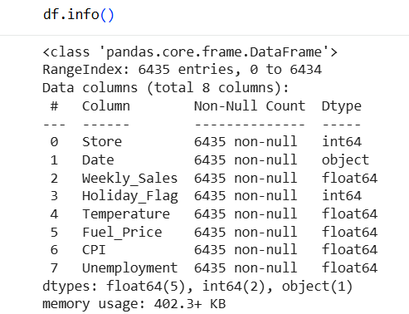

4. Data Cleaning and Preprocessing
The following preprocessing steps were performed:
• Checked for missing values.
• Checked for duplicate records.
• Converted Date column into datetime format.
• Extracted Month and Year features from the Date column.
• Verified data consistency for analysis.
Results
• Missing Values: 0
• Duplicate Records: 0
• Dataset successfully cleaned and prepared for analysis.
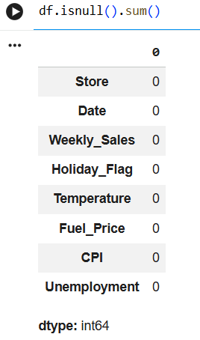
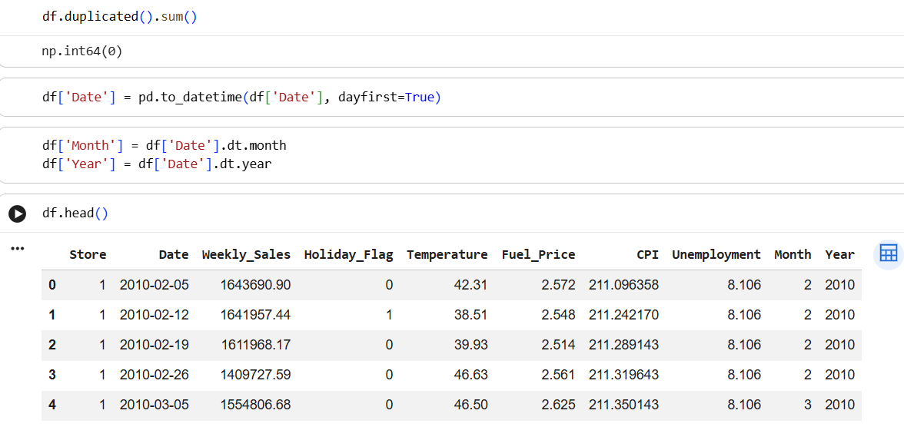

5. Exploratory Data Analysis
5.1 Weekly Sales Trend
A line chart was created to analyze sales trends over time.
Observation:
Weekly sales fluctuate across different periods, indicating seasonal variations and changing customer demand.
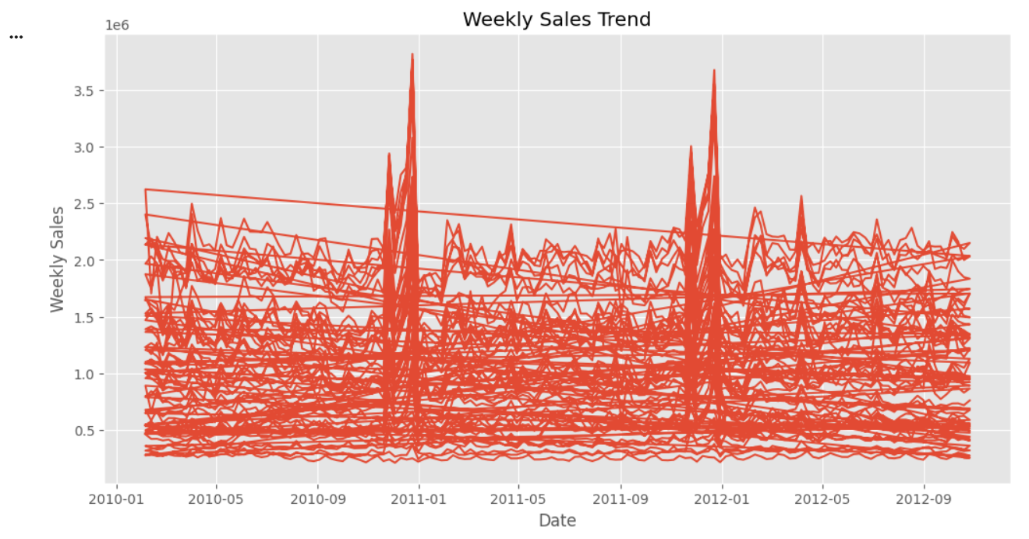

5.2 Average Monthly Sales
Monthly average sales were calculated and visualized.
Observation:
December recorded the highest average sales, followed by November. January showed comparatively lower sales.
Reason:
Holiday shopping and year-end purchases contribute to increased sales during November and December.
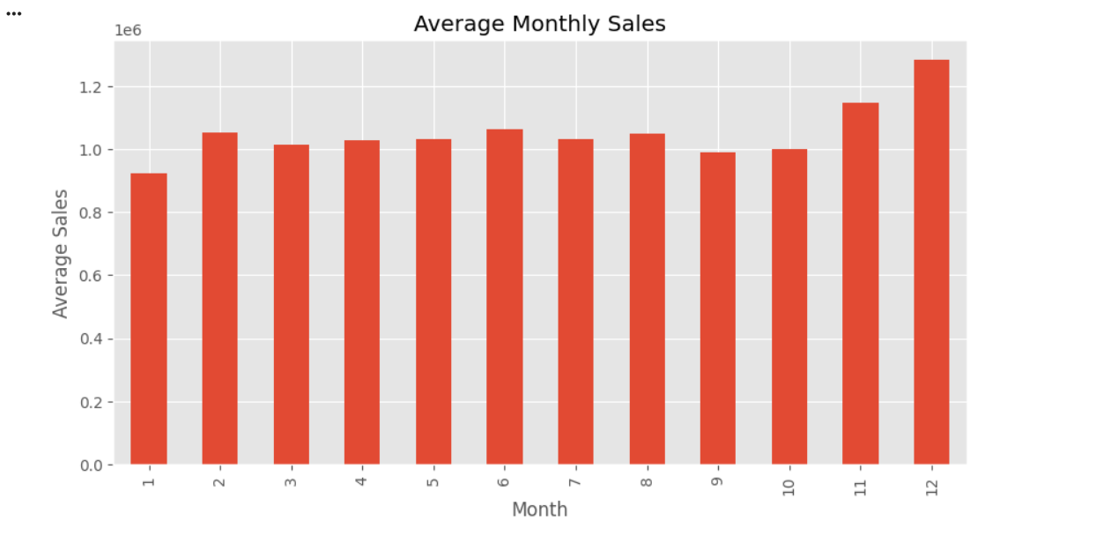

5.3 Store-wise Sales Analysis
Total sales generated by each store were analyzed.
Observation:
Some stores consistently outperform others, contributing significantly to Walmart's total revenue.
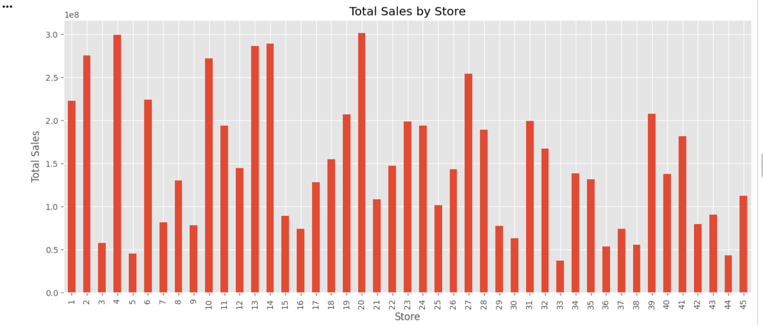

5.4 Holiday vs Non-Holiday Sales
Average sales during holiday and non-holiday weeks were compared.
Observation:
Holiday weeks generated higher average sales compared to non-holiday weeks.
This indicates that customers tend to spend more during holiday seasons.
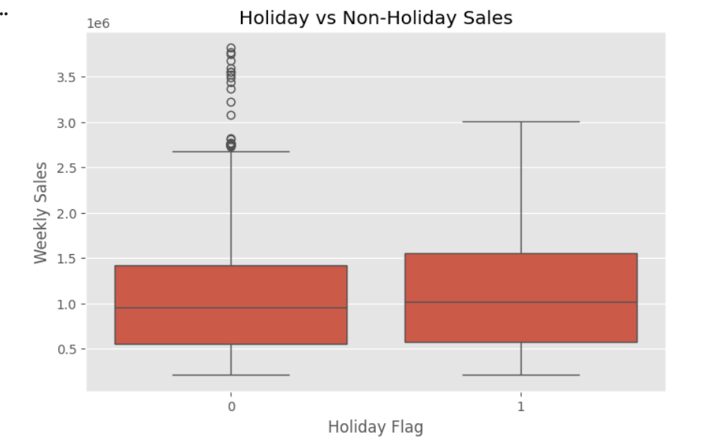

5.5 Correlation Analysis
A correlation heatmap was created to understand relationships between numerical variables.
Observation:
Weekly sales show weak correlation with temperature, fuel price, CPI, and unemployment rate.
This suggests that sales are influenced more by seasonal and store-specific factors.
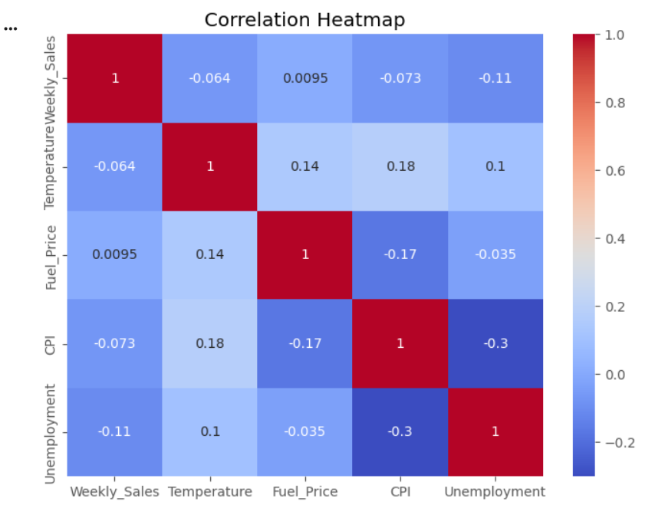

5.6 Top 10 Stores by Sales
The top-performing stores were identified based on total sales.
Top Stores:
Store 20 – 301.40 Million
Store 4 – 299.54 Million
Store 14 – 289.00 Million
Store 13 – 286.52 Million
Store 2 – 275.38 Million
These stores contributed the highest revenue in the dataset.
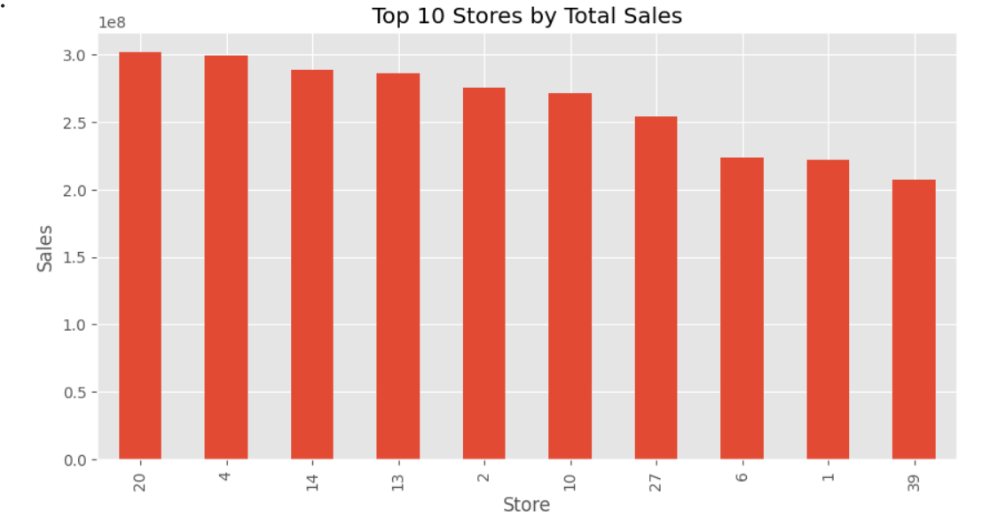

6. Key Findings
• Store 20 generated the highest total sales.
• December recorded the highest average monthly sales.
• Holiday weeks achieved higher sales than non-holiday weeks.
• Seasonal demand significantly affects sales performance.
• Economic indicators showed relatively weak correlation with weekly sales.
• A small number of stores contributed a large portion of total revenue.
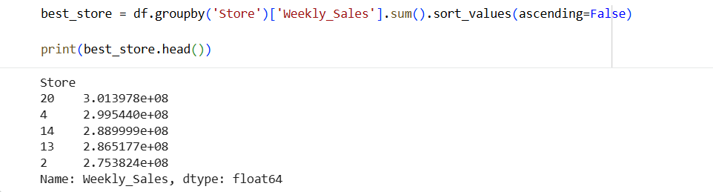
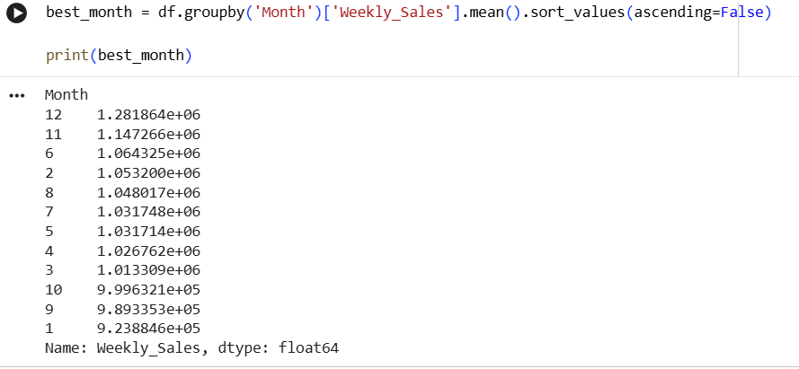
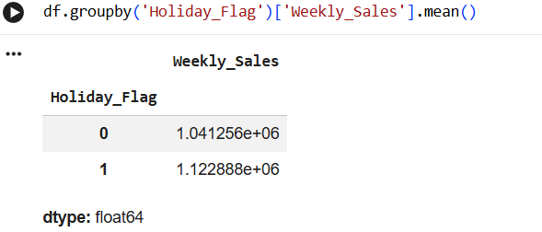

7. Conclusion
This project successfully analyzed Walmart sales data using Python, Pandas, Matplotlib, and Seaborn.
The analysis revealed important sales trends, seasonal patterns, and store performance insights. Holiday periods and year-end months generated higher sales, while certain stores consistently outperformed others.
The findings can help retail businesses improve inventory planning, marketing strategies, and resource allocation.

8. Future Scope
• Build sales forecasting models using Machine Learning.
• Predict future demand trends.
• Analyze store-level performance using advanced analytics.
• Develop interactive dashboards using Power BI or Tableau.
• Perform customer behavior analysis using additional datasets.

